Media Server Configuration

Here is the process used to install and configure a Plex media server on Debian 10. The original tutorial followed can be found here: <https://www.linuxbabe.com/debian/install-plex-media-server-debian-10-buster>.

**Installing Plex**

Plex isn’t included in Debian’s repository, so instead we must get it straight from the Plex website. If the we find the appropriate download link then we can copy it, and download straight from the terminal:

wget https://downloads.plex.tv/plex-media-server-new/1.16.5.1488-deeb86e7f/debian/plexmediaserver_1.16.5.1488-deeb86e7f_amd64.deb

Then we use ***dpkg*** tool to install the package:

Sudo dpkg -i plexmediaserver_1.16.5.1488-deeb86e7f_amd64.deb

Now Plex should be installed, and we can if the service is running and if it isn’t then we can start it:

systemctl status plexmediaserver

systemctl start plexmediaserver

**Enabling the Plex Repository**

If we enable the Plex repository, we can update Plex with the normal ***apt*** package manager like we do for other packages. To enable the repository, you need to edit this file:

sudo nano /etc/apt/sources.list.d/plexmediaserver.list

Then, we uncomment the last line in that file which points to the public *plex.tv/repo/deb/*. As mentioned in the comments of this file, we need to obtain Plex’s public key to the use the repository:

wget -q https://downloads.plex.tv/plex-keys/PlexSign.key -O - | sudo apt-key add –

Finally, we then update our software repository index:

sudo apt update

**Plex Media Server Setup**

First, we need to check what ports the Plex server is listening on. We can do this with:

sudo ss -tlpn | grep Plex

This uses the *nstat* tool (instead of netstat which is now depreciated) to list open ports with the parameters “**-tlpn”** where **t=TCP**, **l=listening**, **p=display processes,** and **n=numeric to display port numbers instead of service names**:

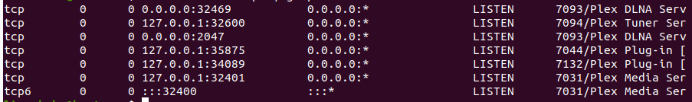

From the screenshot, we can see that the Media Server is listening on two ports: **127.0.0.1:32401** and **:::32400.**

We can then go ahead and access the web-based management interface by entering the following in a web browser:

Localhost:32400/web

This will take us to a webpage which requires us to login with an account. Upon logging in, you can complete the initial setup through the web interface which is relatively self-explanatory.

To finish the initial setup, we need to:

1. Specify a name for our server that will be visible to clients, e.g.: **media1**
2. For this home lab, I have **disabled remote access outside of my network** to the server as it is not needed and to provide an extra layer of security
3. Then we specify the location of our library (which needs read and execute permissions for the user), in this example I chose:

/home/harry/documents/mediaserver/vda

Now the initial setup is complete. As this media server will only host local media and be accessed by one user, I did some additional configuration. This included disabling scanning online sources for media, disabling remote access, setting up a username and password to access the server and whitelisting my only client’s IP.

**Testing the Media Server**

In order to test the media server a video file was downloaded onto the media server (using my FTP server), this video file was then moved to the appropriate folder (**/home/harry/documents/mediaserver/vda**).

From here I was able to play the media file via the web interface both on the server itself and from **Apollo** (My host Windows PC) meaning that the server had been successfully setup.

To access the server from a client, go to <https://serverIP:32400/web/> and enter a username and password if prompted.